**ECPI University Rafat Khandaker**

**CIS 228 09/30/18**

**Unit 5: Graded Exercise**

**Scenario 1: (Set Time on Closing Cache in Chrome)**

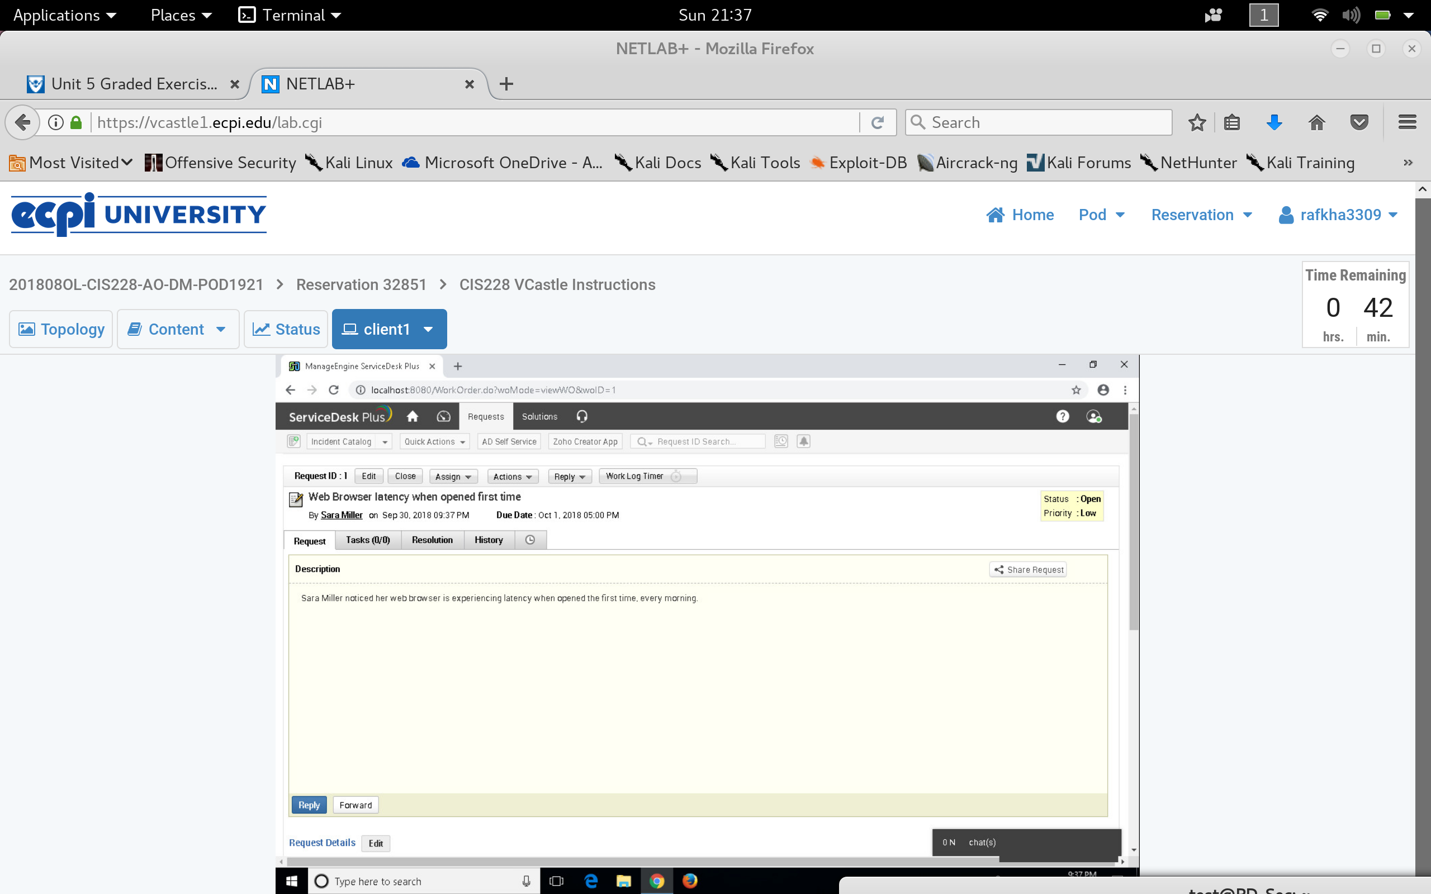

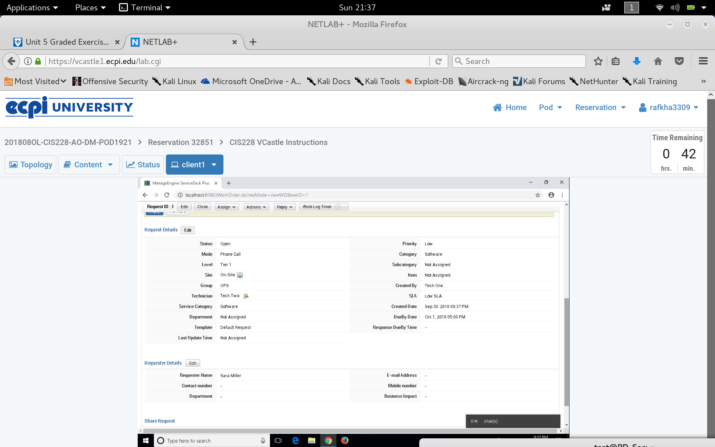

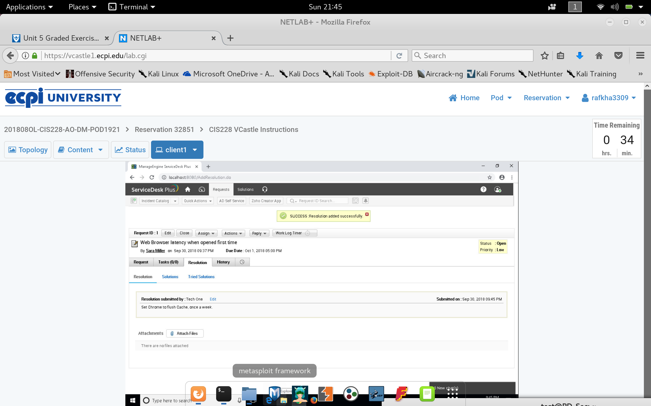

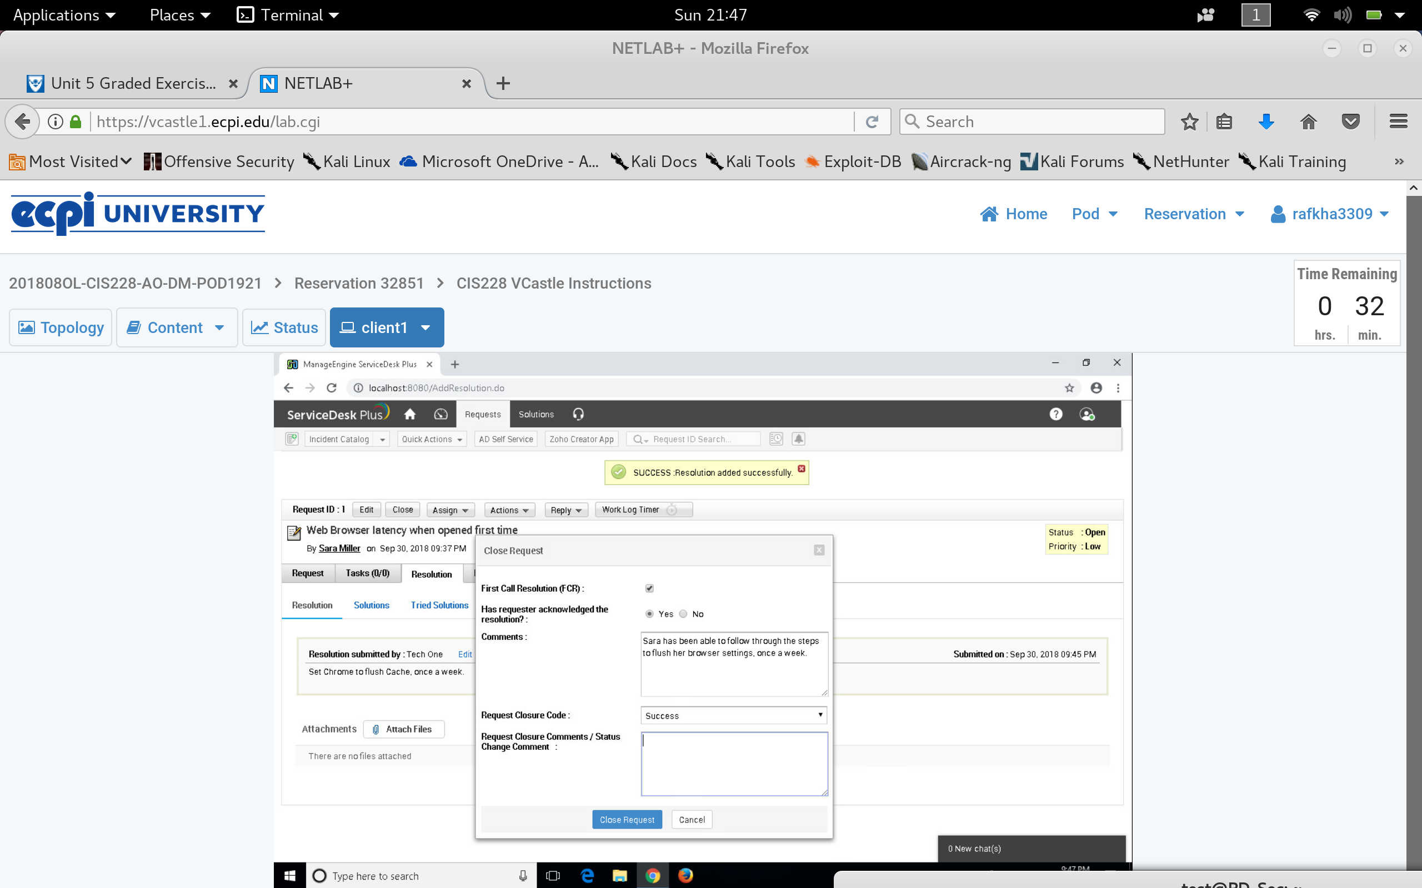

**Scenario 2: (Save Favorites to bookmark)**

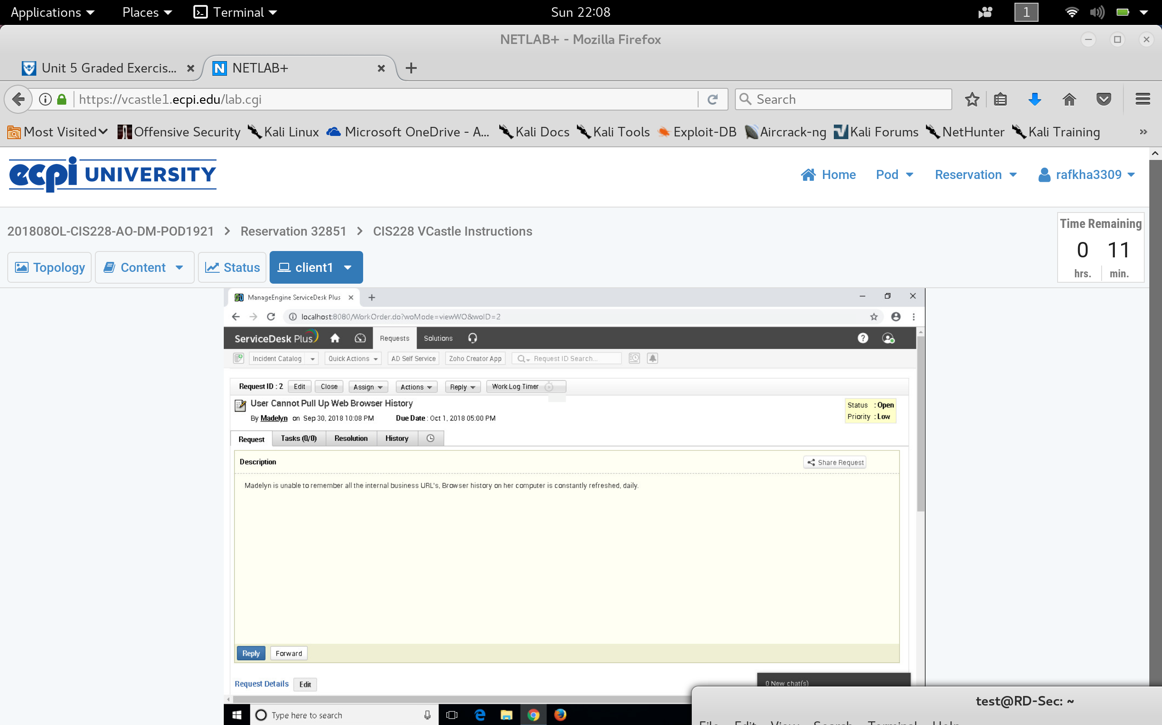

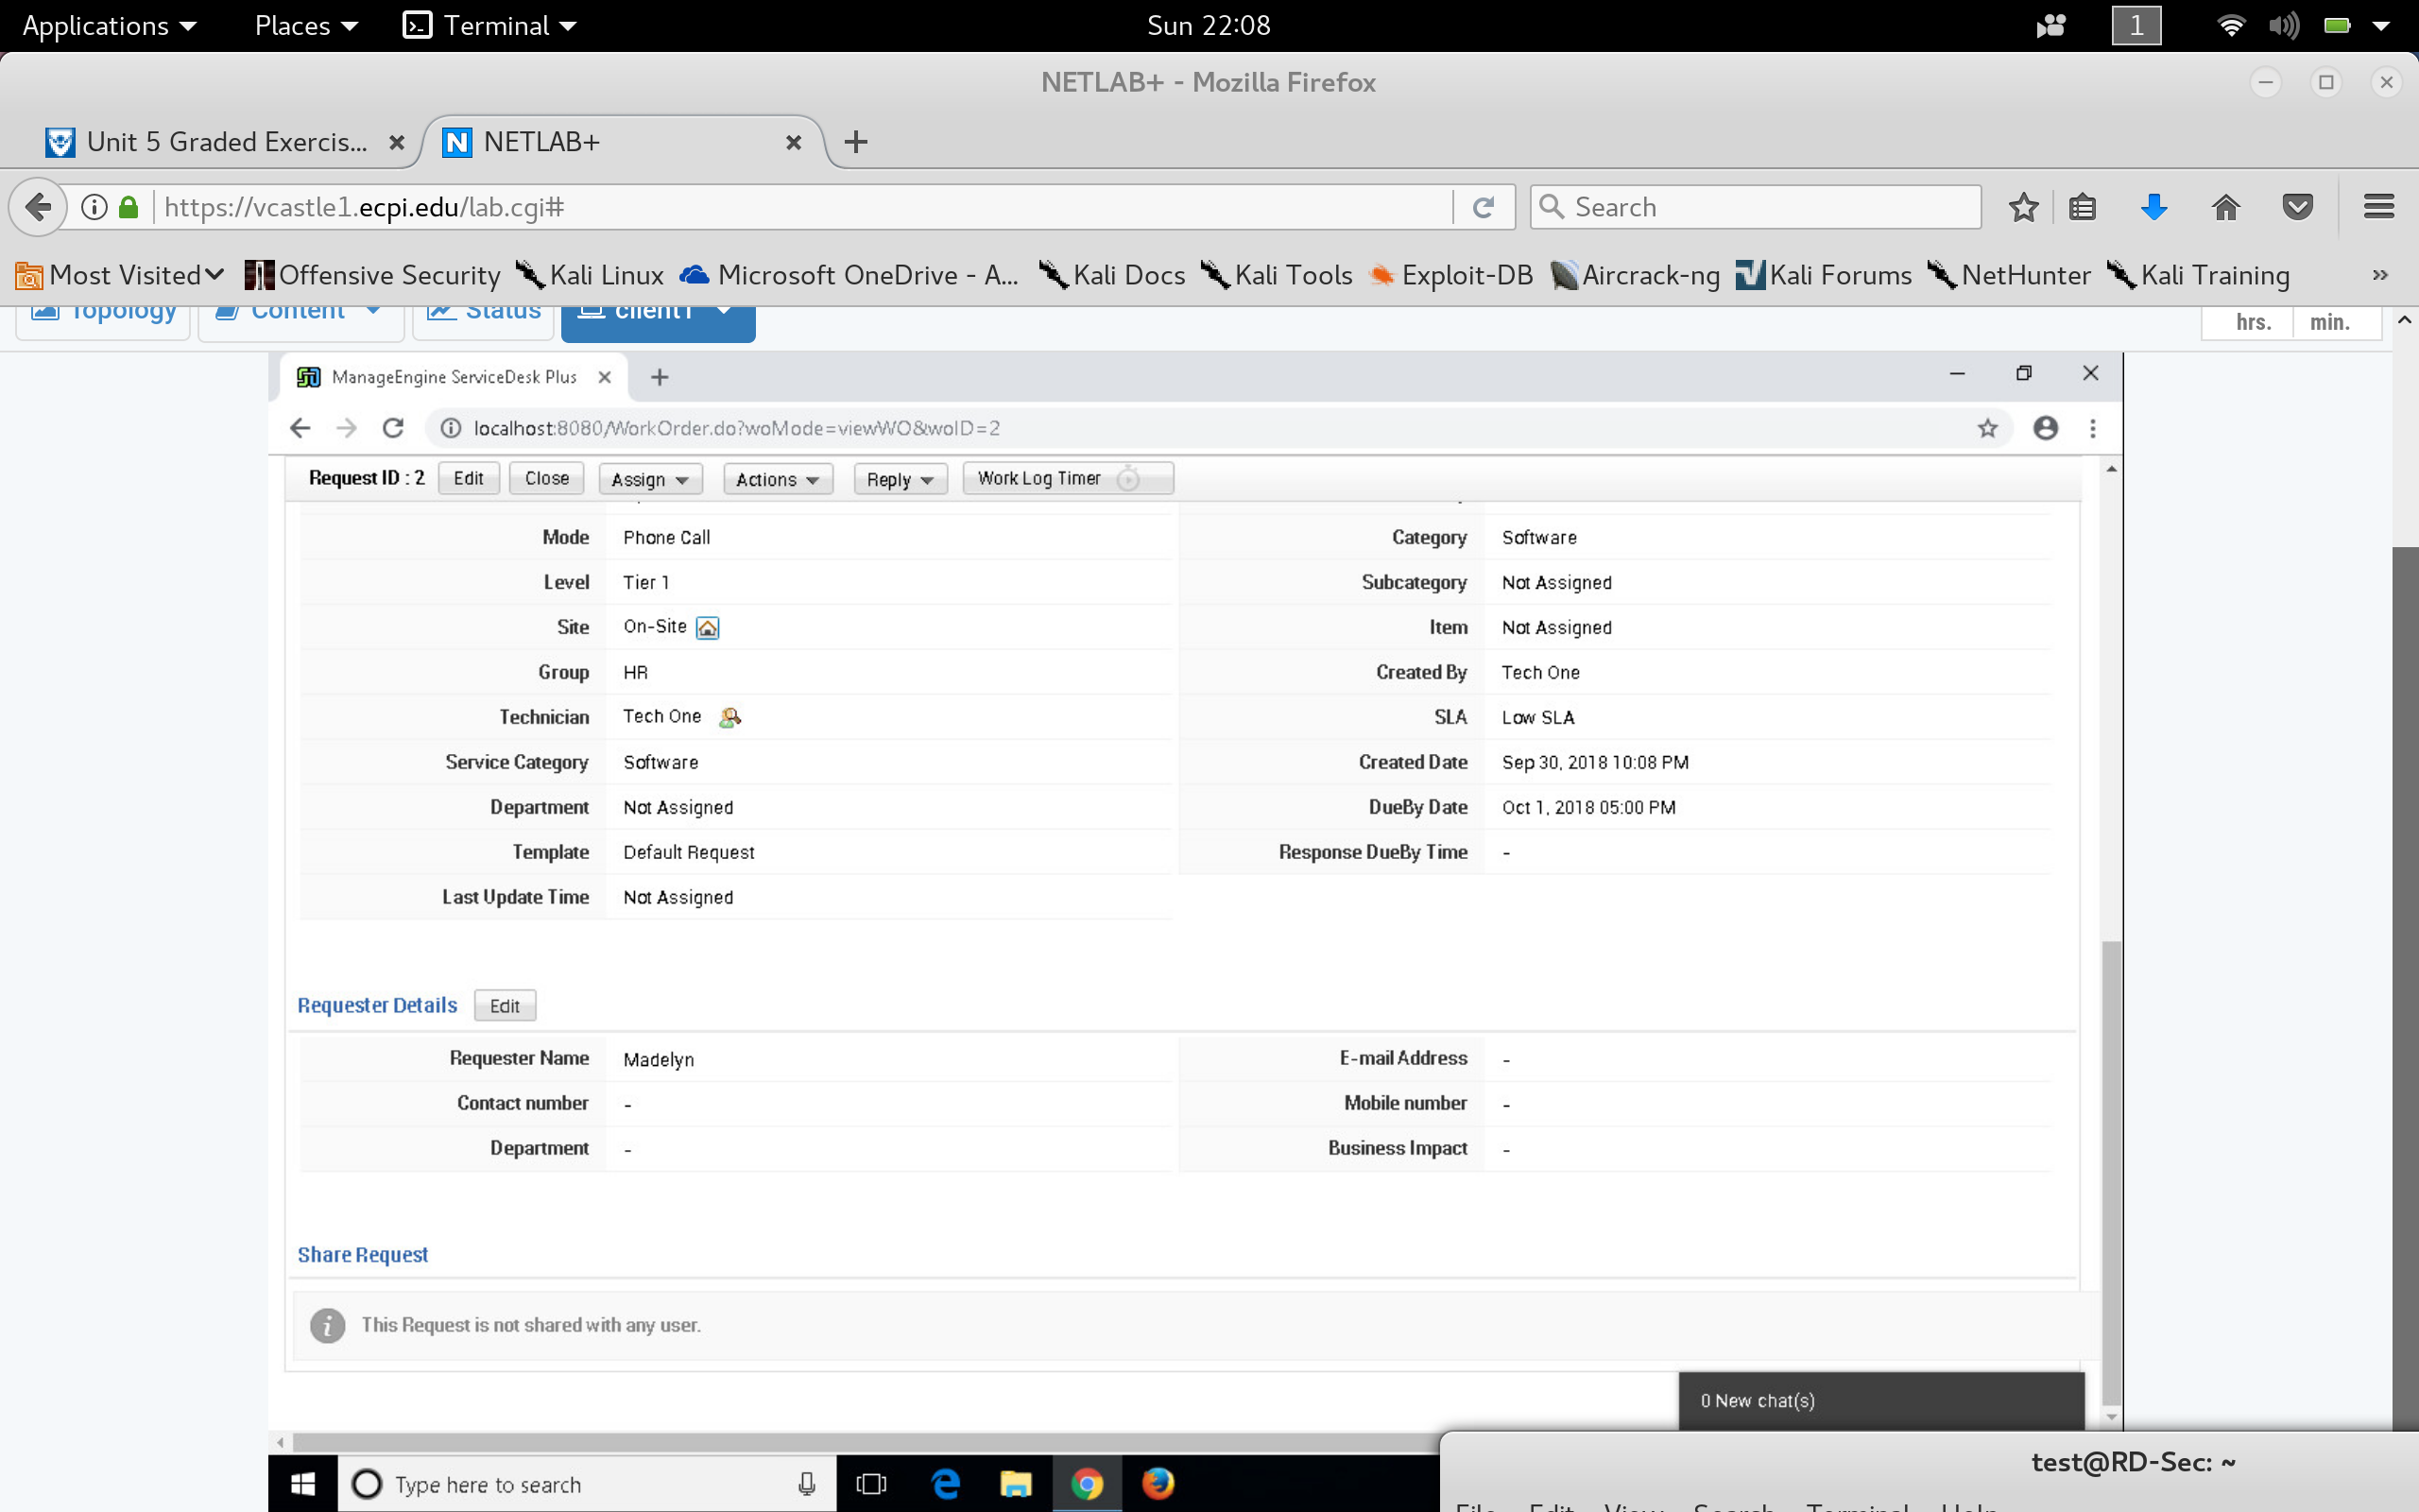

Madelyn’s TIcket was resolved first time.

She was able to follow through the steps to set up her URL Bookmark.

**Scenario 3: (Enable Cookies)**

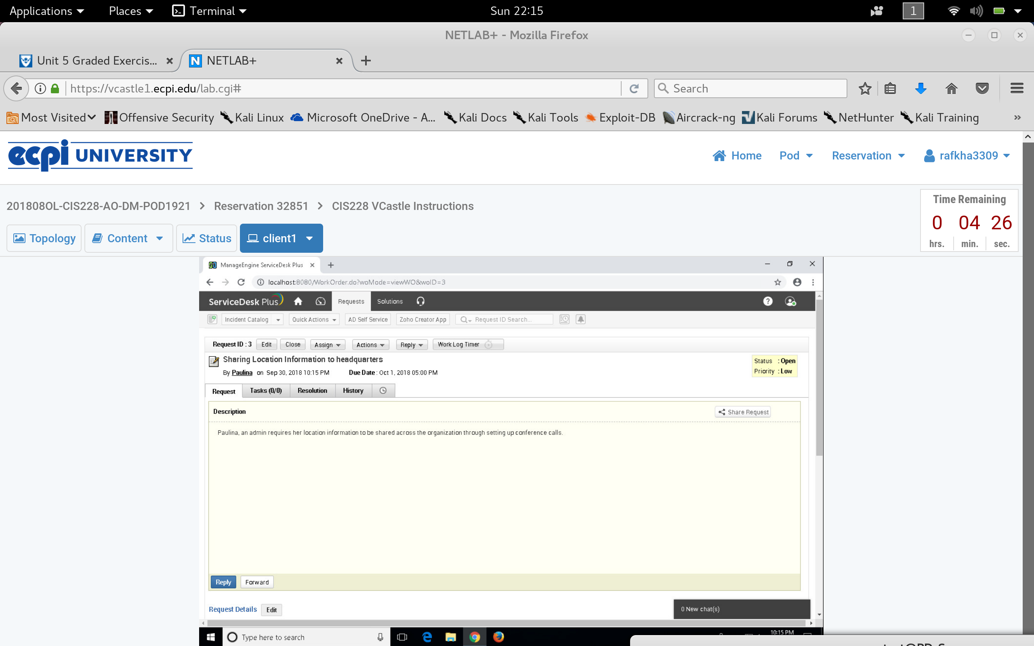

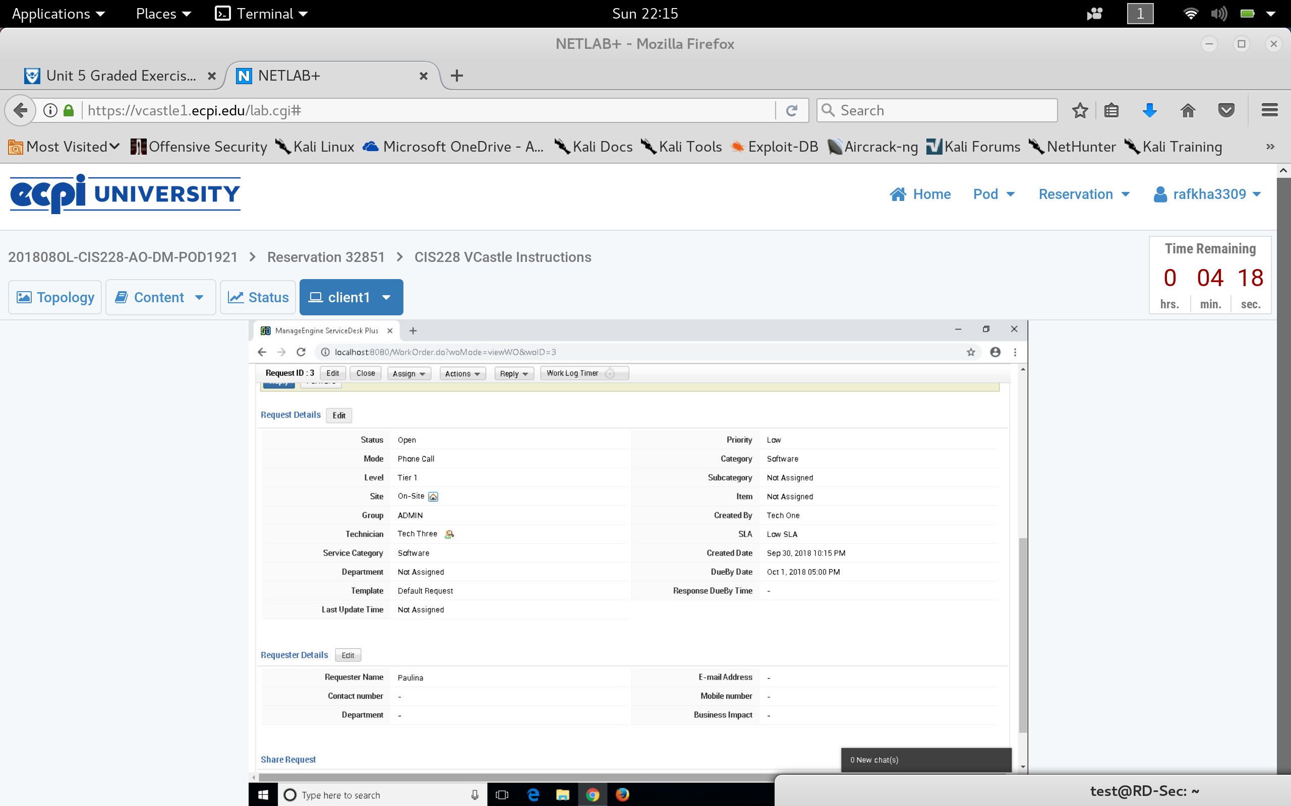

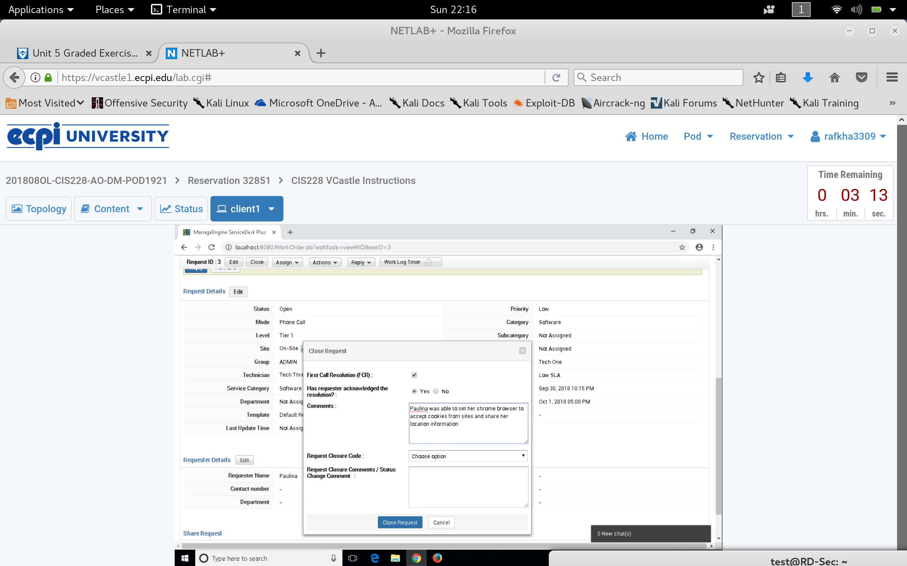

**Scenario 4: Set Default Browser**

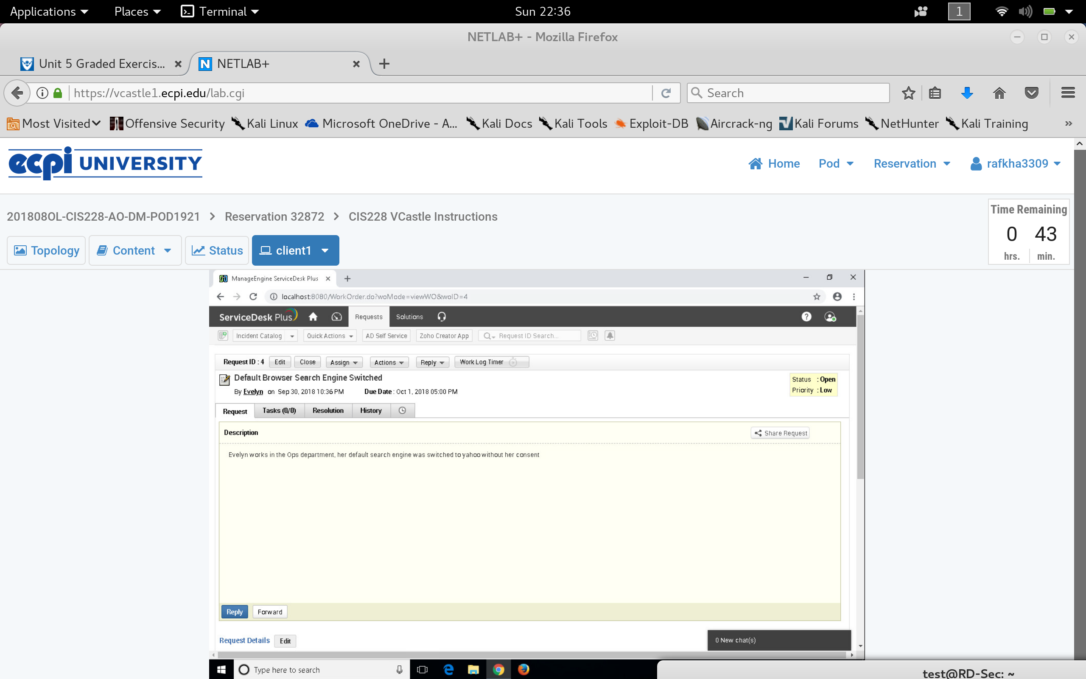

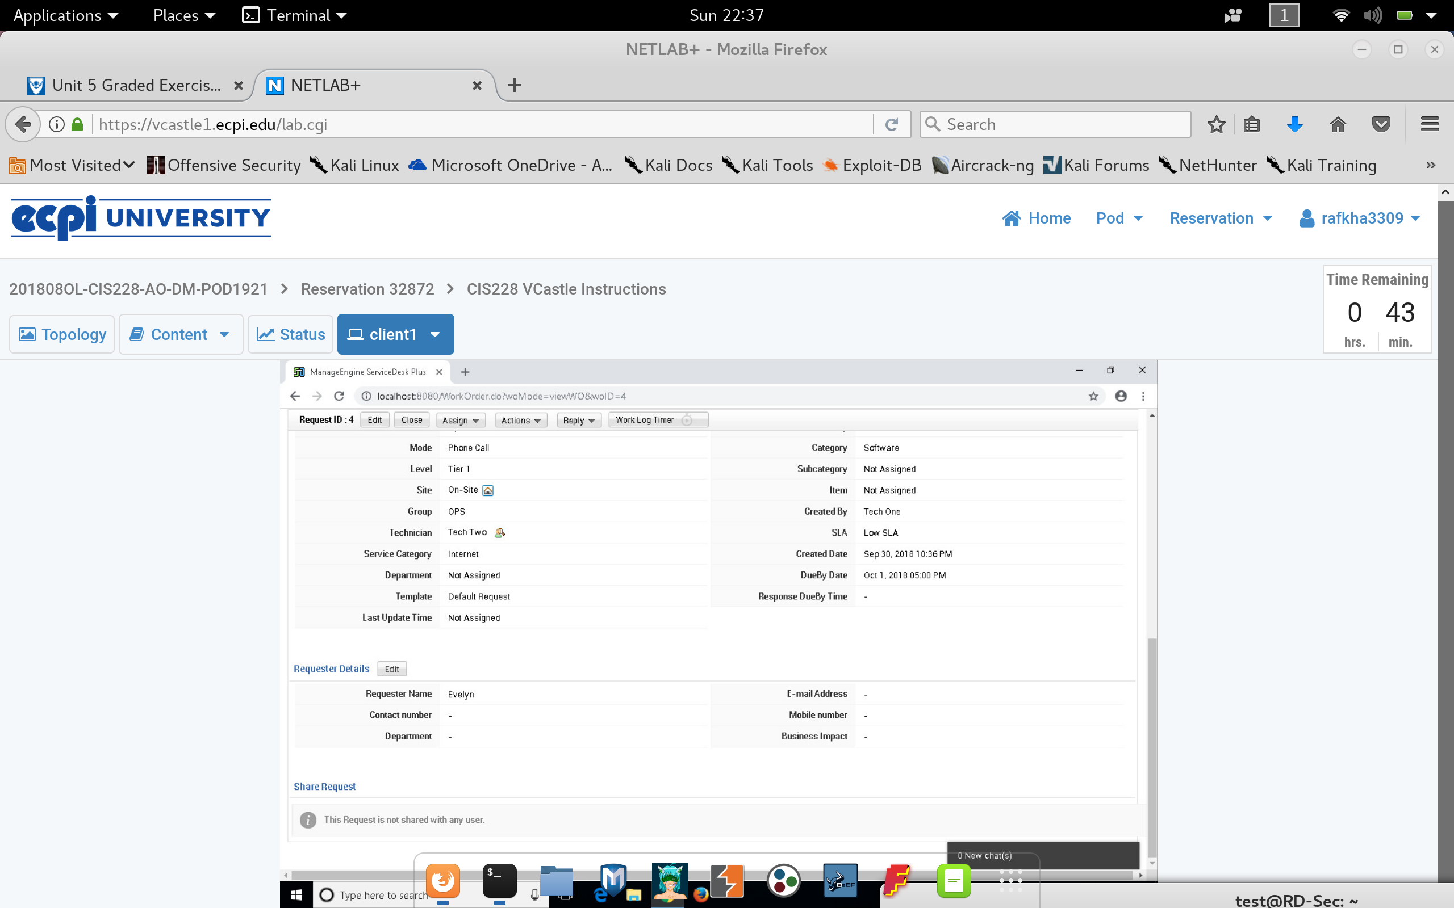

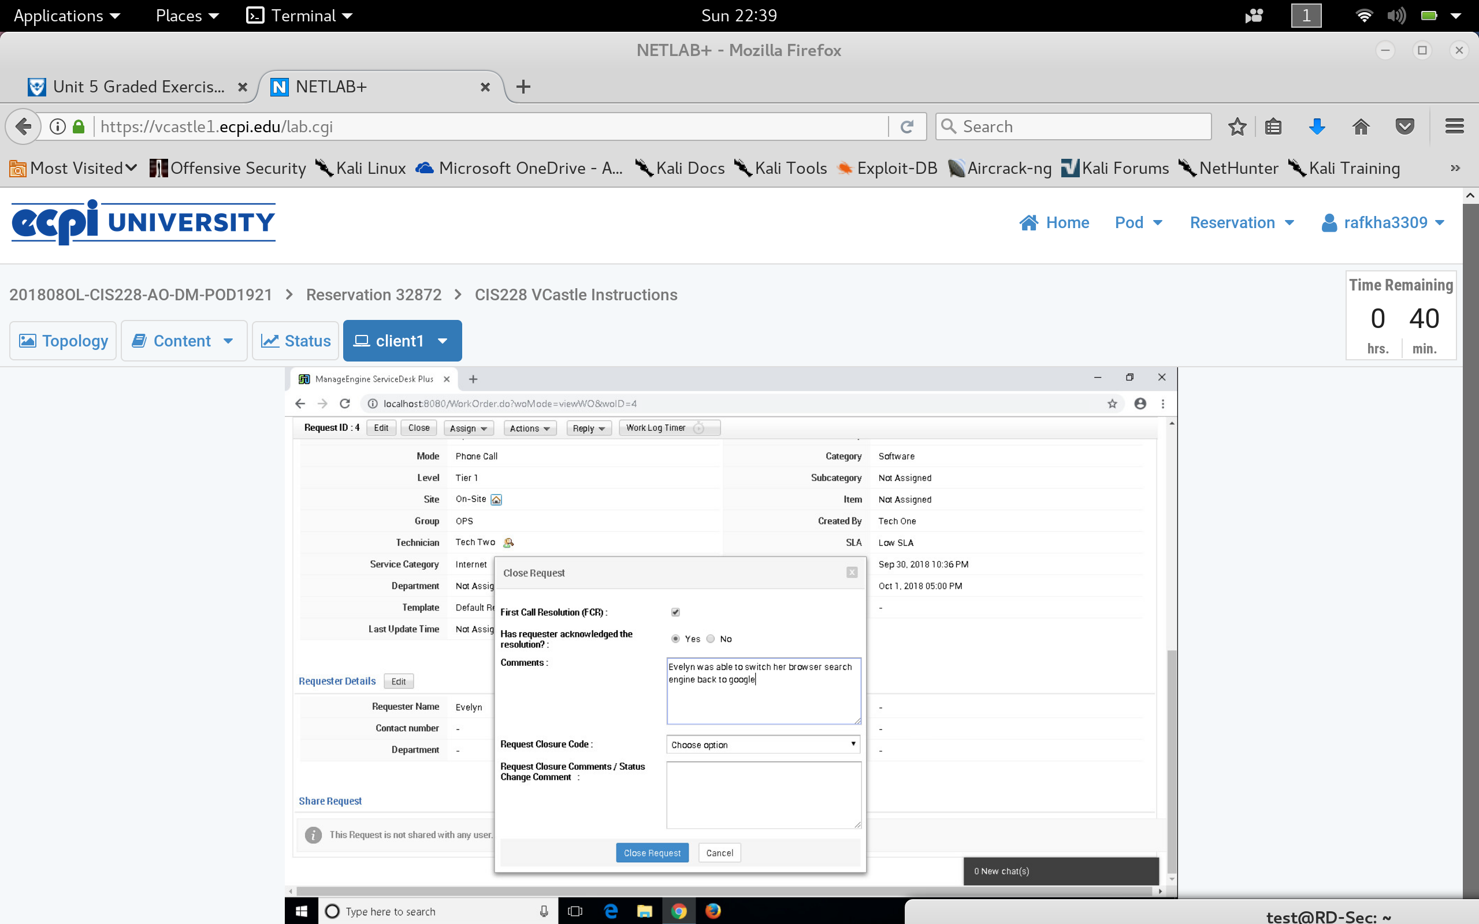

**Scenario 5 Enable Pop-ups**

